Featured Launch: Calendar audit
Easy troubleshooting using Calendar audit

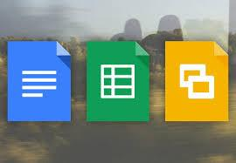 | Work together  Edit icons for Office files in Gmail desktop attachments  Conversion support for additional Microsoft® Office formats  Smarter sharing in Drive and Docs  Complete ODF file format support and more for Google Docs editors

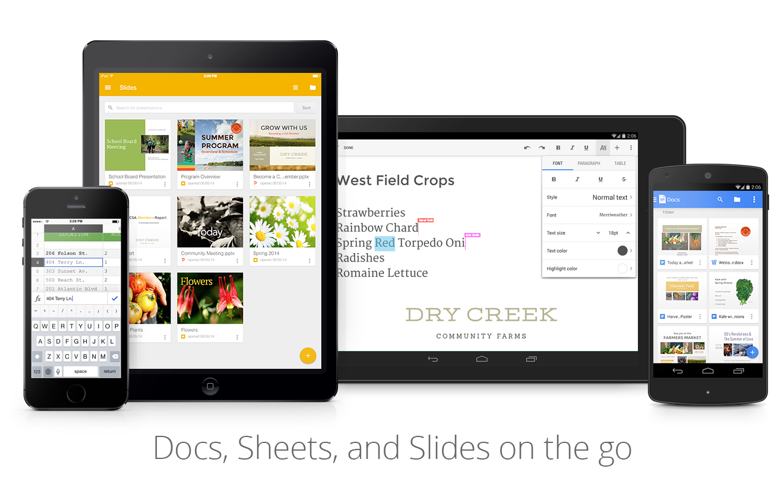 | Work anywhere  Better editing of tables and shapes in the Docs editors iOS apps  Line spacing, shape editing and more in the Docs editors Android apps  Search and content improvements for the Google Drive Android, iOS apps

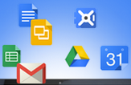 | Simple to use  Table cell merging in Google Docs  Adjust image color and filters in Google Docs  Slide numbers in Google Slides  New sparkline options in Google Sheets  New UI language in Gmail: Irish (Gaeilge)  Sharing Drive files as attachments in Gmail  Custom status messages for Google Hangouts  Add image to Gmail signature from Google Drive

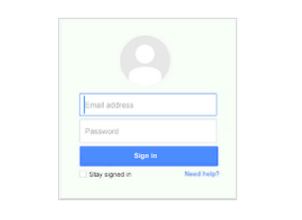 | Business ready  Quota for Calendar API v3 now 10 times higher  New reports, policies and more for iOS Sync  Admin provisioning of Google+ profiles for organizational units

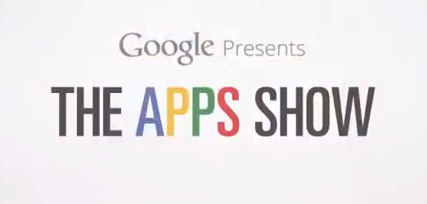 | Learn more about Google Apps  The Apps Show on YouTube  What’s New for Apps Admins videos

We’d really appreciate your thoughts on how we can make this newsletter work best for you.

-The Google Apps Team
January 5, 2015

Featured Launch: Calendar Audit

Easy troubleshooting using Calendar Audit
Released December 11, 2014 Share with your organization

What’s new: Sometimes Calendar events change―like an event being deleted or updated, the removal of a booked room, or a change to a list of invitees―and it’s not clear how those changes came about. With this launch, admins can use the new Calendar audit feature in Admin Reports to see details of specific user actions within Google Calendar.

You can see changes to primary calendars―like deleting or creating a new calendar―along with changes to events like description, time, name or guest list, and even changes to notifications and reminders.

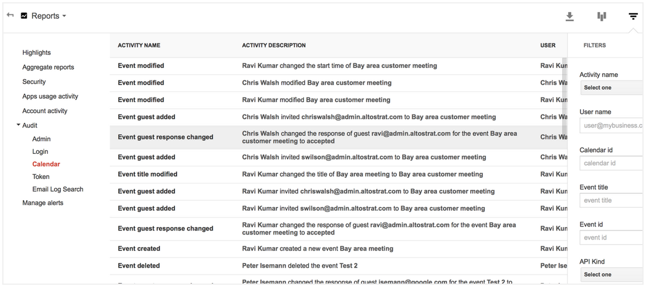

How it works: To access the Calendar audit reports in Admin console, click on Reports > Audit > Calendar. Calendar audit data is also available via the Reports API for Calendar activity.

Note: this feature is not available for Google Apps for Government customers

Learn more in the Help Center.

Work together

Edit icons for Office files in Gmail desktop attachments
Released December 2, 2014 Share with your organization

What’s new: In Gmail, with a single click on the pencil icon in the attachment card, you can now convert any Office files sent as attachments to Google Docs, Sheets, or Slides. You can then start editing and enjoying the full benefits of a single document to keep track of, access from anywhere, and full revision history.

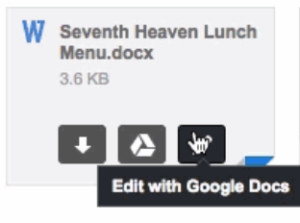
Learn more in the Drive G+ announcement and the Help Center.

Conversion support for additional Microsoft® Office formats
Released December 2, 2014 Share with your organization

What’s new: We know some of you work with Office files regularly, so we’re adding conversion support in Google Docs, Sheets, and Slides for 15 new Office file formats.

New formats supported include:
- dot, dotx, dotm*, docm* conversions to Google Docs
- xlt, xltx, xltm*, xlsm* conversions to Google Sheets
- pot, potx, potm*, pptm*, pps, ppsx, ppsm* conversions to Google Slides
We’ve also added better conversion support for charts, SmartArt, and merged table cells in your Office documents.

How it works: After the conversion, you can edit, collaborate on, and share your file online. When you convert a file, the original file will remain intact and accessible from Google Drive.

*Note: Macros will be removed from macro file formats upon conversion

Check out the Drive G+ announcement and Help Center for more information.

Smarter sharing in Drive and Docs
Released December 11, 2014 Share with your organization

What’s new: We introduced two new features to help make working together even easier in Google Drive and the Google Docs editors.

After you add an email address to the sharing dialogue, you’ll see profile pictures for everyone you’ve added. This can come in handy when you need to confirm that you’re inviting the right contacts, especially if you work with people that have similar names.

We’re also making it easier to add people who you typically share with. Once you add two collaborators, you’ll see suggestions for related people who you frequently email or share files with:

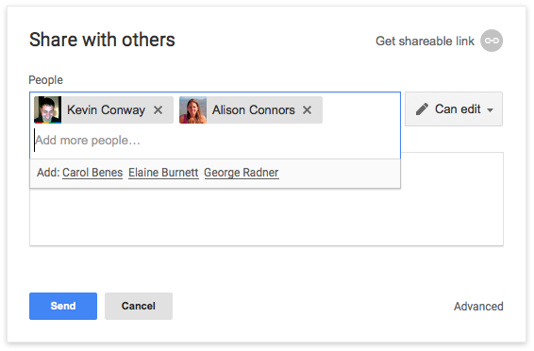

How it works: Open the sharing dialogue and start typing in the names of people with whom you want to share. Their profile pictures will appear and additional collaborators will automatically be suggested after you add the first two.

Read more in the Help Center.

Complete ODF file format support and more for Google Docs editors
Released December 16, 2014 Share with your organization

What’s new: We now support importing all three major ODF (Open) file formats: .odt files for documents, .ods for spreadsheets, and .odp for presentations.

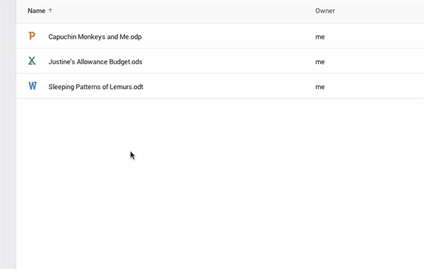

How it works: Right click on your ODF files from Google Drive and select ‘Open with,’ then select Google Docs, Sheets, or Slides accordingly.

Learn more in the Help Center.

Work anywhere

Better editing of tables and shapes in the Docs editors iOS apps
Released December 8, 2014 Share with your organization

What’s new: New versions of the Google Docs, Sheets, and Slides apps for iOS are now available in the App Store. New features include:  - Support for viewing and editing text in tables in the Docs app  - Ability to insert, move, resize and rotate text boxes, shapes and lines in the Slides app  - Enhanced support for iPhone 6/6+ (all apps)  - General fixes and performance improvements (all apps) | 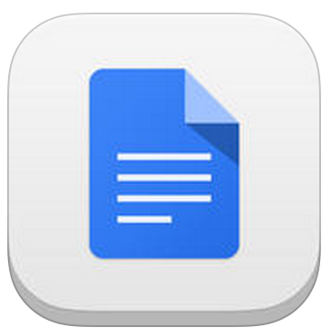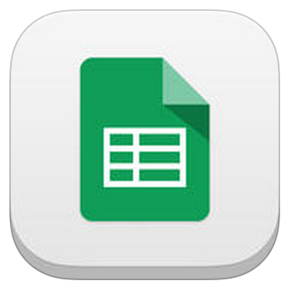  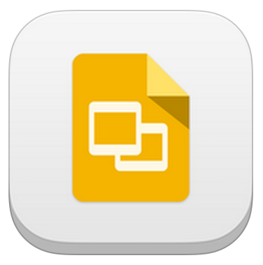
Get the Google Docs, Sheets, and Slides apps in the App Store.

Line spacing, shape editing and more in the Docs editors Android apps
Released December 15, 2014 Share with your organization

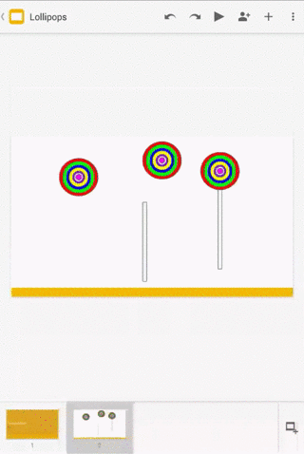 | What’s new: New versions of the Google Docs, Sheets, and Slides apps for Android are now available on Google Play.  The Docs app now has line spacing controls that let you choose single, double or fractional line spacing, the Sheets app has new scrollbars for faster navigation, and the Slides app now supports inserting, moving, resizing, and rotating text boxes, shapes, and lines.  All three apps are now even friendlier with Office files with easier file creation and other updates, and we’ve added better accessibility options.  Get the Google Docs, Sheets, and Slides apps on Google Play

Search and content improvements for the Google Drive Android, iOS apps
Released December 17, 2014 Share with your organization

What’s new: We’ve added some helpful new features to the Google Drive apps for Android and iOS.  On Android, you can now search for files in Drive from the Google app. For example, you could say “OK, Google — search for team meeting notes on Drive” and find files in the Drive app without having to open the app and type in your search query. | 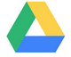

On iPhone and iPad, you can now get more of your content in Drive by uploading it from other iOS apps.

Get the Drive app for Android and iOS.

Simple to use

Table cell merging in Google Docs
Released December 1, 2014 Share with your organization

What’s new: We added the ability to merge the cells of a table in Google Docs. Merged table cells can span more than one row and/or column. Merged table cells in Word documents can now be imported as well.

How it works: To merge table cells, highlight the cells to be merged in your table and select Merge cells from the Table menu (or right click and select Merge cells).

Check out the Help Center for more information.

Adjust image color and filters in Google Docs
Released December 1, 2014 Share with your organization

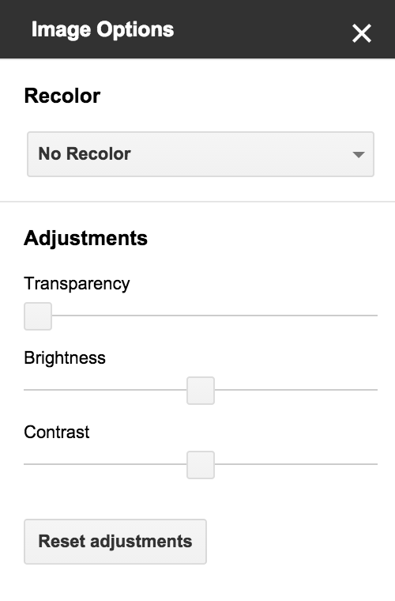 | What’s new: As recently launched for Google Slides, people working with images in Google Docs on the web will now have the ability to adjust their color, transparency, brightness, and contrast.  How it works: To use this feature, select an image in Google Docs and click the Image options button in the toolbar (you can also right click on the image, or use the Format menu, and select Image options).  Under "Recolor," you can change the color of your image to match your document.  Under "Adjustments," you can change the transparency, brightness, and contrast of the image:  Read more in the Help Center.

Slide numbers in Google Slides
Released December 1, 2014 Share with your organization

What’s new: People using Google Slides can now add slide numbers to their presentations, providing a reference guide for both presenters and audiences.  How it works: To add slide numbers, go to Insert > Slide numbers from the toolbar. You can then choose to apply slide numbers to all slides or selected slides. You can also choose to skip title slides.  Check out the Help Center to learn more. | 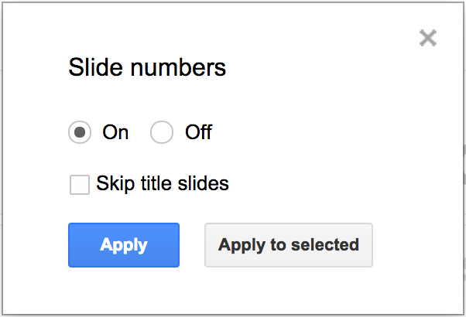

New sparkline options in Google Sheets
Released December 9, 2014 Share with your organization

What’s new: The SPARKLINE function in Google Sheets creates a miniature chart contained within a single cell, providing a quick visual depiction of data trends. With this launch, we added two new types of sparklines - column and winloss - joining the existing line graph and bar chart options:

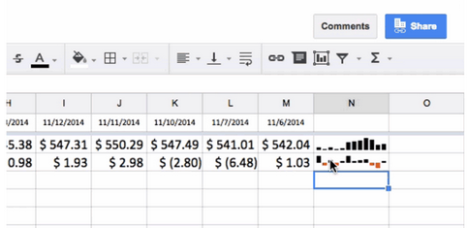

How it works: See the Help Center for details on using the SPARKLINE function.

New UI language in Gmail: Irish (Gaeilge)
Released December 11, 2014 Share with your organization

What’s new: People using Gmail now have the option to view the Gmail UI in Irish (Gaeilge), the 72nd different language offered.

How it works: Language settings can be changed from the “display language” drop-down in Settings.

Note: One’s display language doesn't affect the language in which messages are sent and received.

See the Help Center for more information.

Sharing Drive files as attachments in Gmail
Released December 15, 2014 Share with your organization

What’s new: Previously, when composing an email in Gmail, people had the option to share Google documents and other files stored in Google Drive via links by clicking on the ‘Insert files using Drive’ button.

With this launch, we enabled the option to share files in Drive as attachments, allowing the file owner to remove the source file from Drive if so desired, without needing to worry about also removing access to the file from recipients.

How it works: When clicking on ‘Insert files using Drive,’ you’ll now see the buttons below in the lower right corner of the insert window. Clicking the Attachment button will add your selected file as an attachment. Inserting files as Drive links will be the default option:

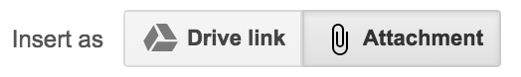
Notes:
- This feature only applies to files that weren't created in Drive (so Google Docs, Sheets, Slides, etc will not work)
- Gmail attachments have a 25MB limit
Check out the Help Center to learn more.

Custom status messages for Google Hangouts
Released December 17, 2014 Share with your organization

What’s new: People using Google Hangouts on the web can now add custom status messages and see the status messages of others in the Contacts view.  How it works: Status messages can be added via the settings menu. By default, they will be displayed outside of the domain, though admins have the option to restrict them to be displayed within the domain only via Admin console at Apps > Google Apps > Talk/Hangouts > Sharing Settings.  Note: Hangouts status messages are only visible to others using Hangouts. They are not shared to people using Google Talk. Similarly, status messages set in Google Talk will not be shared to Hangouts. | 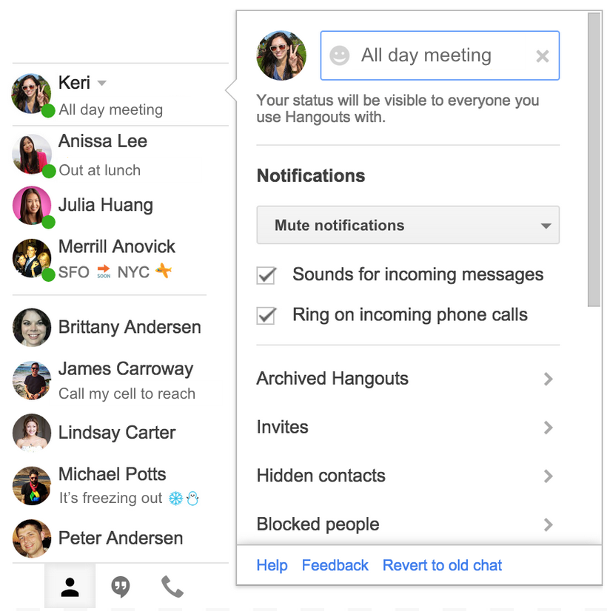

This feature is coming soon for the Hangouts Android and iOS apps.

Learn more in the Google for Work G+ announcement and the Help Center.

Add image to Gmail signature from Google Drive
Released December 22, 2014 Share with your organization

What’s new: We’ve made it easier to add images to Gmail signatures on the web by enabling the option to choose and display images from Google Drive.

How it works: Images can be added in Gmail Settings > General. In the ‘Signature’ section, click the ‘Insert image’ icon above the signature text box and add your image from Drive:

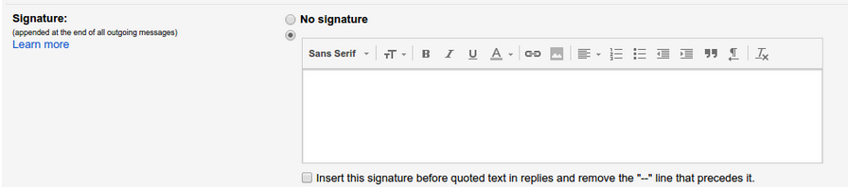

Note: In order for this feature to be visible in Gmail, admins will need to enable external sharing of Drive files in Admin console: Drive > Sharing settings > Sharing options.

Learn more in the Help Center.

Business ready

Quota for Calendar API v3 now 10 times higher
Released December 4, 2014

What’s new: We increased the default quota for the Calendar API v3 by a factor of ten, to 1 million requests per day. That means your application can support ten times as many users without any need to apply for more quota.  If you need even more free quota, you can apply for it in the developer console under APIs -> Calendar API -> Quota -> Apply for higher quota.  We have also streamlined the process of quota handling to make sure you receive your quota as quickly as possible.  Tips to work efficiently with your quota: | 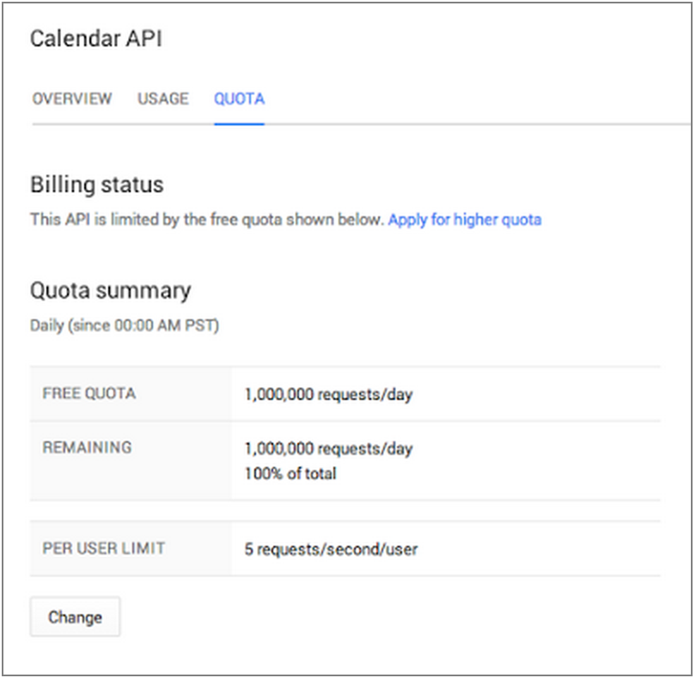
- Use push notifications instead of polling.
- If you cannot avoid polling, make sure you only poll when necessary (for example poll very seldomly at night).
- Use incremental synchronization with sync tokens for all collections instead of repeatedly retrieving all the entries.
- Increase page size to retrieve more data at once by using the maxResults parameter.
- Update events when they change, avoid re-creating all the events on every sync.
- Use exponential backoff for error retries.

Read more in the Google Developers blog post.

New reports, policies and more for iOS Sync
Released December 11, 2014

What’s new: Earlier this year, we launched a new iOS Mobile Device Management (MDM) solution known as iOS Sync for Google Apps, which integrates Google mobile apps with native iOS device management.

We’ve now launched several new features and improvements for iOS Sync, including:

Security policies
- Backup policies
  - Require encrypted backups
  - Allow user to back up to iCloud
  - Allow user to back up docs and key-values to iCloud
  - Allow user to back up keychain to iCloud
- Lockscreen policies
  - Allow user to show control center on lock screen
  - Allow user to show notifications on lock screen
  - Allow user to show “today” view on lock screen
Reporting
- Updated reports in the Admin console UI:
  - Managed Devices (7 day, 30 day active)
  - Managed Users (7 day, 30 day active)
  - Managed Android devices (7 day, 30 day active)
  - Managed iOS devices (7 day, 30 day active)
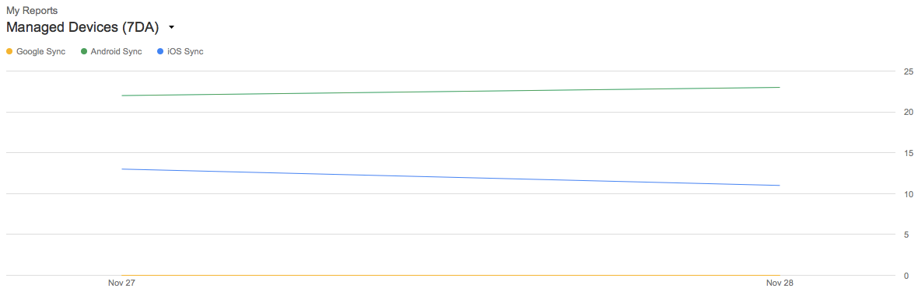
- New reports features:
  - New line charts to help admins see trends in OS version and Sync-type reports
  - Added new sync type: iOS Sync
  - Added support newer versions in reports (e.g., iOS 8)
- Device info refresh to include IMEI, OS Version, device model and serial number
  - See Device management > Mobile > Managed devices in the Admin console to view refreshed information for individual devices
How it works: From the Admin console, the updated 7/30 day active reports can be accessed from the Reports > Aggregate reports > My Reports drop-down. By default, three of the new reports are selectable from the drop-down, and more may be added to the selection list by visiting Select reports > Mobile.

Check out the Google for Work G+ post and the Help Center for more information.

Admin provisioning of Google+ profiles for organizational units
Released December 11, 2014

What’s new: Last month, we launched the capability for Google Apps admins to give individual users a Google+ profile, in order to connect with other employees and encourage collaboration and sharing in the organization. We’re now extending this capability so that admins can perform automatic profile upgrades for an entire organizational unit (OU).

How it works: From Apps > Additional Google Services > Google+ > Sharing settings, admins can simply select an OU that has been enabled for Google+ and check the box in Profile Creation settings to automatically create Google+ profiles for all members of the OU.

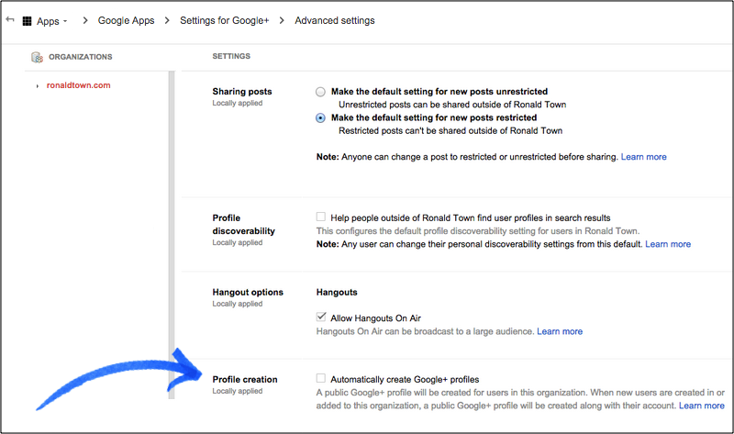

After confirming that all people in the OU are older than 18 (and that no users under 18 will be added to the selected OU), Google+ profiles are then automatically created for all existing (and future) members of the OU. These members are then sent a Google+ welcome email explaining the action taken by the administrator.

Notes
- This launch applies to Premier, Government, and higher-education EDU domains only (K-12 EDU domains are excluded).
- People using Picasa or with a public chat photo are not eligible to be upgraded by an admin, and must create their own profile.
Check out the Google for Work G+ post and Help Center (admin | user) to learn more.

Learn more about Google Apps

Google Apps for all: The Apps Show on YouTube, every Wednesday, 11am PST
Share with your organization

What’s new: In December, The Apps Show aired its first customer story from Shannon Rose, a realtor at Keller Williams, on how she uses Calendar and Gmail to manage her various client accounts. The first Shortcuts, a one minute video featuring a pro tip from a Googler, also debuted. Regular episodes also continued to run, including this popular episode on change management stories.  To know: We’d like to show you how more customers and Googlers work in future episodes. Let us know what you’re interested in seeing by commenting on our latest episode.  Bookmark The Apps Show playlist on YouTube | 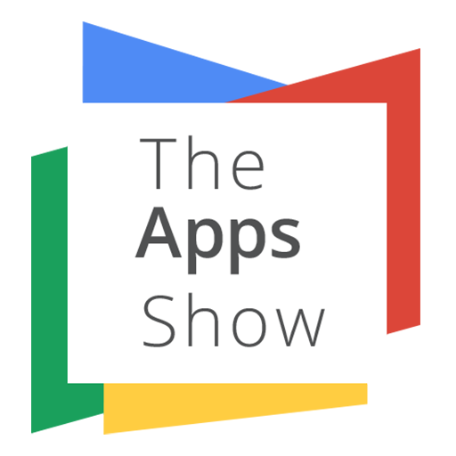

What’s New for Apps Admins videos
Share with your organization
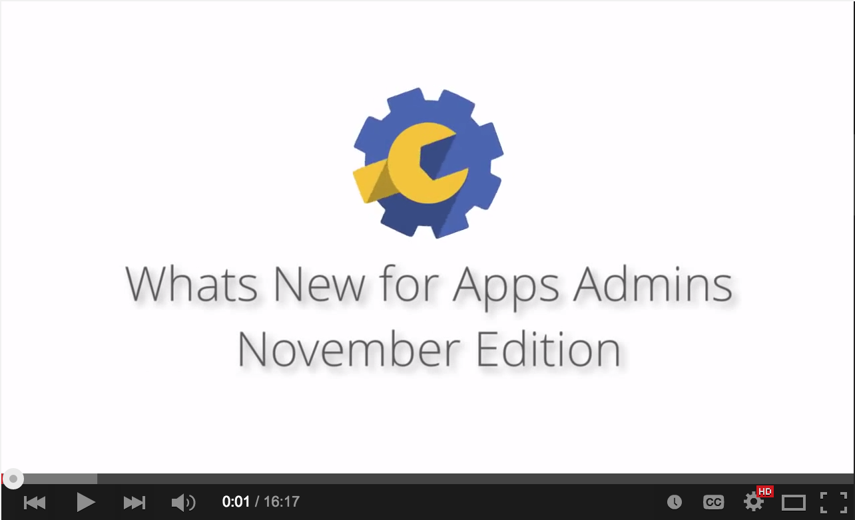 | What’s new: We’ve changed the format of (and renamed) our popular What’s New in Google Apps webinar series from scheduled live sessions to video recordings hosted on YouTube, so you can watch and share them whenever you want.  How it works: The What’s New for Apps Admins videos provide a recap of all of the features we've released in the past month that are relevant to Google Apps admins.

Bookmark the playlist on YouTube and check back each month for the latest updates. You can also access all video recordings in the archive on the What’s New site.

Thanks for checking out our newsletter!
We’d really appreciate your thoughts on how we can make this work best for you.

