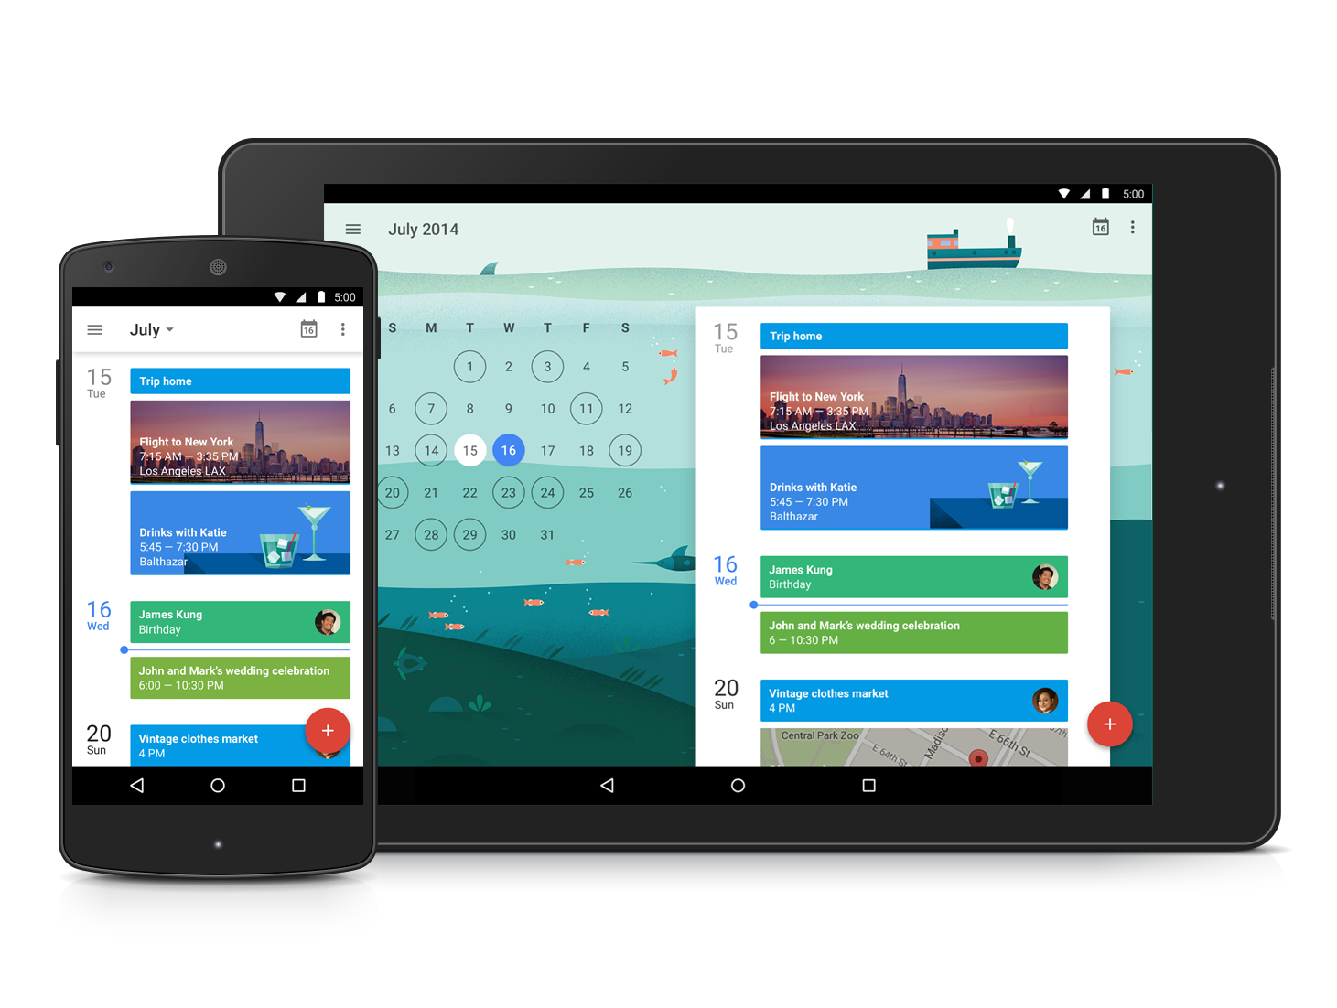 | Featured Launch: New Google Calendar app  Get the most out of every day with the new Google Calendar app  - Material design: sleek new look and feel  - Assists: suggestions that save you time  - Schedule View: easy to scan and lovely to look at

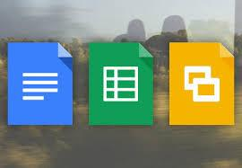 | Work together  Better collaboration in Hangouts video calls

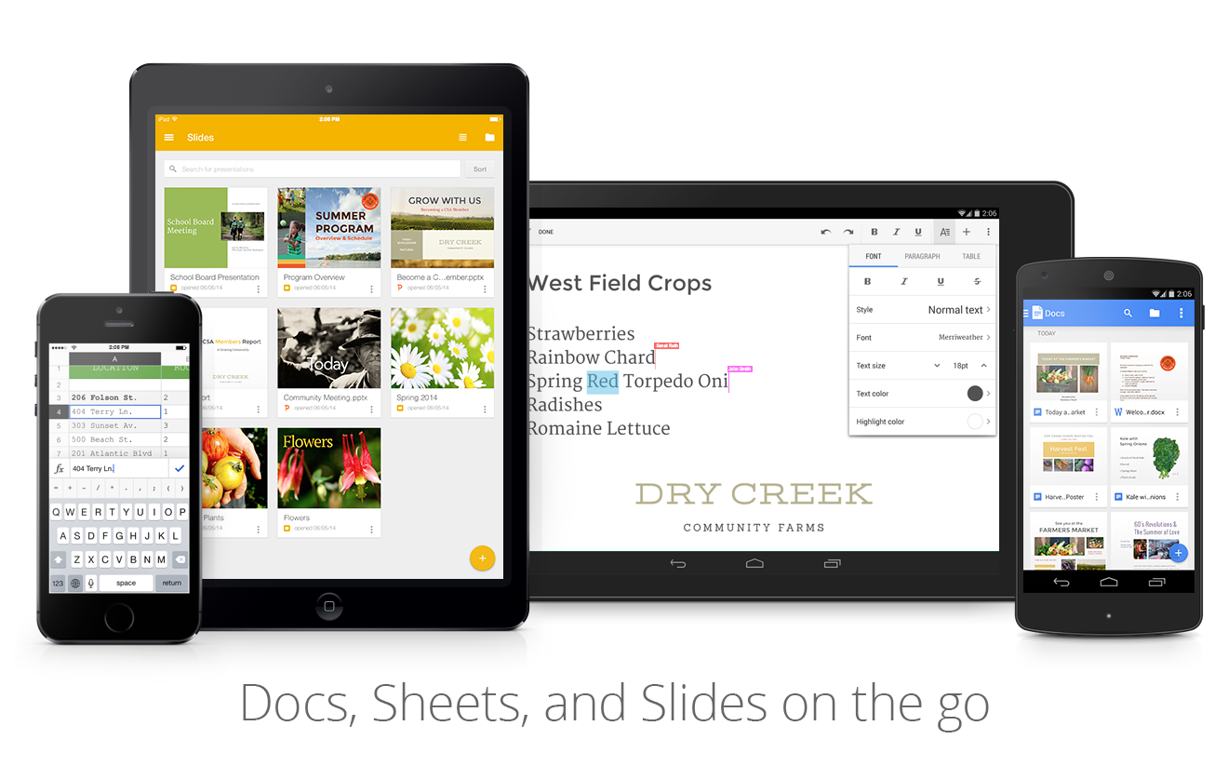 | Work anywhere  A more modern Gmail app for Android  New version of the Google Drive iOS app

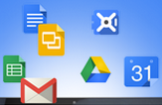 | Simple to use  Launch desktop applications from Google Drive in Chrome

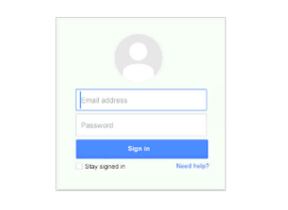 | Business ready  New Gmail reports added to aggregate reports dashboard  Increased visibility and control with OAuth token audit reporting  Admin provisioning of individual Google+ profiles  Admin control of link sharing for Hangouts video calls  New tools to help improve online security

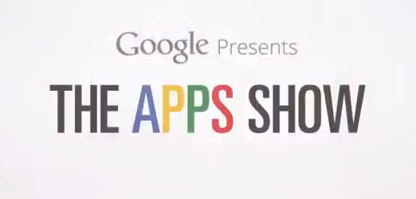 | Learn more about Google Apps  The Apps Show on YouTube  What’s New for Apps Admins videos  Google Apps tips for Sales and Marketing professionals

We’d really appreciate your thoughts on how we can make this newsletter work best for you.

-The Google Apps Team
December 1, 2014

Featured Launch: New Google Calendar app

Get the most out of every day with the new Google Calendar app
Released November 3, 2014 Share with your organization

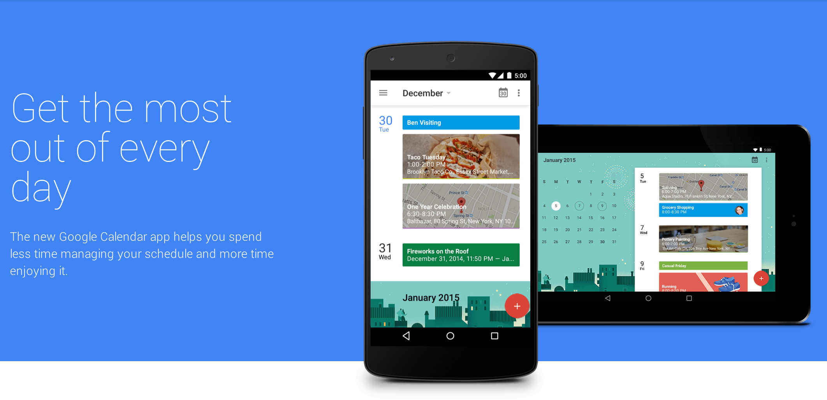
On November 3rd, we introduced a brand new Google Calendar app, built to save you time and help you make the most of every day. Key features of the app include:

Material design: sleek new look and feel
As with other Google products adopting material design principles, the new app features smooth animations and transitions between screens, quick access to the elements that you need most often, and a colorful UI with diverse fonts and styles.

Assists: suggestions that save you time
When creating a calendar event, we often have to piece together phone numbers, addresses and attendees from lots of different sources, then add them to our calendars manually. With Assists, Calendar can suggest titles, people and places as you type, as well as adapt to your preferences over time. For example, if you often have lunch with your mentor Kelly, Calendar can quickly suggest this when you type ‘l-u-n.’

Schedule View: easy to scan and lovely to look at
Calendar’s new Schedule view includes photos and maps of the places you’re going, cityscapes of travel destinations, and illustrations of everyday events like dinner, drinks and yoga. These images will bring a little extra beauty to your day, and make it easy to see what’s going on at a glance—perfect for when you’re checking in from your phone or tablet.

The new Google Calendar works on all Android 4.1+ devices. It’s available now on all devices running Android 5.0 Lollipop, and can be downloaded (or updated) for Android 4.1+ devices from Google Play. We’re also working hard on a version for iPhone.

Check out the Calendar website and announcement on the Google for Work blog.

Work together

Better collaboration in Hangouts video calls
Released November 19, 2014 Share with your organization

What’s new: To make it easier to collaborate during Hangouts video calls, we’ve enabled the sharing of links to any Drive file directly from the chat window. Shared links will show a preview of the file right in the chat message, even when other participants don’t have their chat window open. Clicking on the link will open the file in a different browser tab so you can conveniently work on it in full view.  How it works: To share a link from Drive during a Hangouts video call, click on the Chat icon and then click the Google Drive picker icon from within the chat window. | 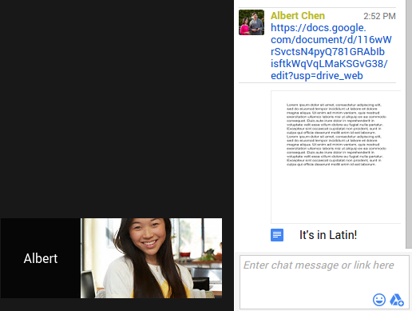

Note: this feature will replace the Google Drive Hangouts app, which will no longer be available as of December 15th, 2014.

Read the Google for Work G+ post and check out the Help Center for more information.

Work anywhere

A more modern Gmail app for Android
Released November 3, 2014 Share with your organization

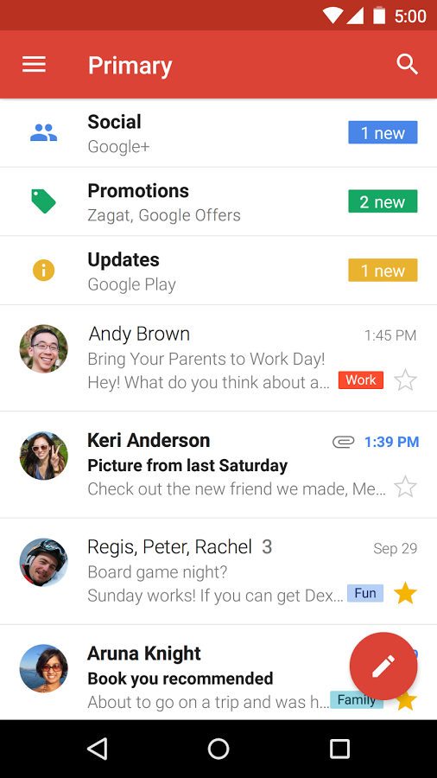 | What’s new: The Gmail app for Android has been updated with a more modern style, sleeker transitions, and a few other handy improvements.  As part of the new design, there’s now a convenient reply button at the bottom of every message, making it quick and easy to continue a conversation when you’re on the go. And if you access the app on your Android tablet, you’ll notice it’s easier to switch between accounts and the different inbox categories.  The updated Gmail app also now supports all email providers, which means you can set up a separate inbox for, say, your Yahoo Mail or Outlook.com addresses using POP/IMAP.  How it works: The new app will support all Android 4.0+ devices. It’s available now on all devices running Android 5.0 Lollipop and can be downloaded (or updated) for Android 4.1+ devices from Google Play.  Check out this instructional guide for a deep dive into the new features and UI elements of the app.
Learn more in the Google for Work blog post and watch the launch video on YouTube.

New version of the Google Drive iOS app
Released November 6, 2014 Share with your organization

What’s new: A new version of the Google Drive iOS app, optimized for iOS 8, is now available in the App Store. The app includes some new security and convenience features, including:  - Open files from Drive, and save back to Drive, from other apps on your device (iOS 8 only)  - Unlock Drive using Touch IDーwe’ve offered the ability to Passcode Lock the Drive app for a while now, so today’s update makes it even easier to keep your files safe (iOS 8 only)  - Save videos from Drive to your device’s camera roll (tap File Info icon > Open In > Save Video)  Learn more in the Drive G+ post and get the Google Drive app in the App Store | 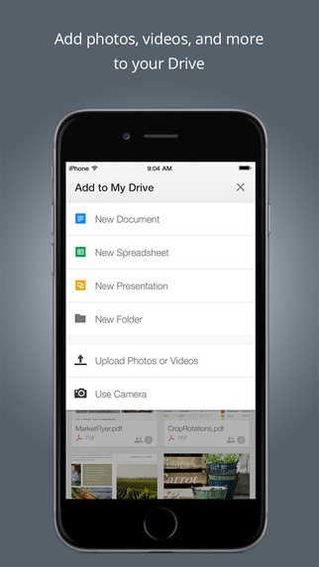

Simple to use

Launch desktop applications from Google Drive in Chrome
Released November 5, 2014 Share with your organization

What’s new: We launched a new extension for Chrome that lets you open files from Google Drive directly into a compatible application installed on your computer. This includes apps like advanced image and video editing software, accounting and tax programs, or 3D animation and design tools. So, no matter what you keep in Drive, using the web to access and manage files doesn’t mean you’re limited to using applications that only work in your browser.

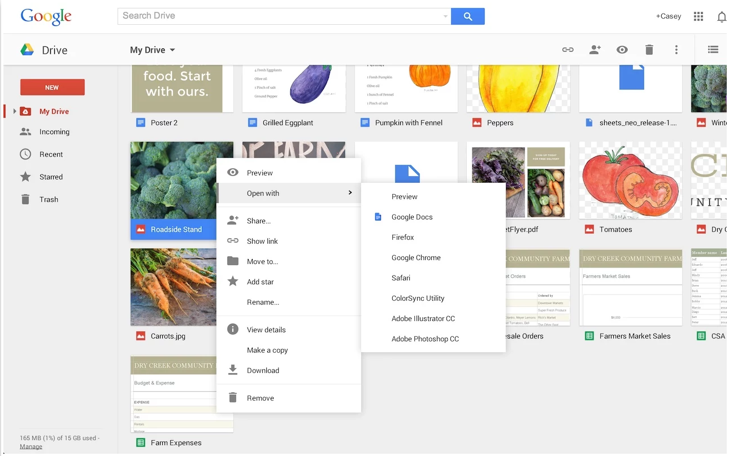

How it works: To get started, install the latest version of the Drive app for Mac or PC and sync your files. Then, visit Google Drive in your Chrome browser (make sure you’re on the new Google Drive). Finally, right-click on the file and select “Open with” to see a list of compatible applications on your computer that can open it. For example, you can choose to open a PDF file with Adobe Reader, or a .psd with Photoshop, make your edits and save back changes to Drive which will sync across all your devices and other collaborators.

Check out the Help Center and Google for Work blog post to learn more.

Business ready

New Gmail reports added to aggregate reports dashboard
Released November 3, 2014

What’s new: Building on the recent launch of aggregate reports in Admin console, we’ve launched additional time-series reports for Gmail, with the goal of providing admins more visibility into mail flow. New reports include:  - Outbound Mail Delivery  - Outbound Mail Encryption  - Inbound Mail Delivery  - Inbound Mail Encryption  - Inbound Spam  For more detail on these new reports, check the Gmail section of the aggregate reports Help Center article.  How it works: To access the aggregate reports dashboard, sign in to the Admin console and click Reports > Aggregate Reports.  Check out the Help Center to learn more. | 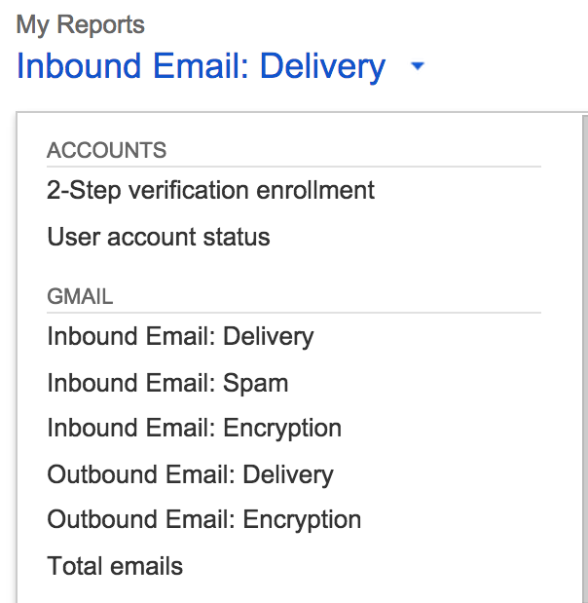

Increased visibility and control with OAuth token audit reporting
Released November 13, 2014

What’s new: People using Google Apps can authorize any third party mobile or web application which supports login with a Google Apps account using OAuth to read their account data (e.g. Contacts, Calendar, Drive files, etc) to integrate with Google Apps. Each authorization grants an access token, which is then logged in the Apps Admin console. Prior to this launch, admins could review the current state of OAuth tokens granted by people within their domain using the security tab, but could not access the change logs of authorized and revoked tokens.

With this launch, we added a new audit report that allows admins to view ‘authorize’ and ‘revoke’ events for OAuth tokens within the Admin console Reports section and the Reports API.

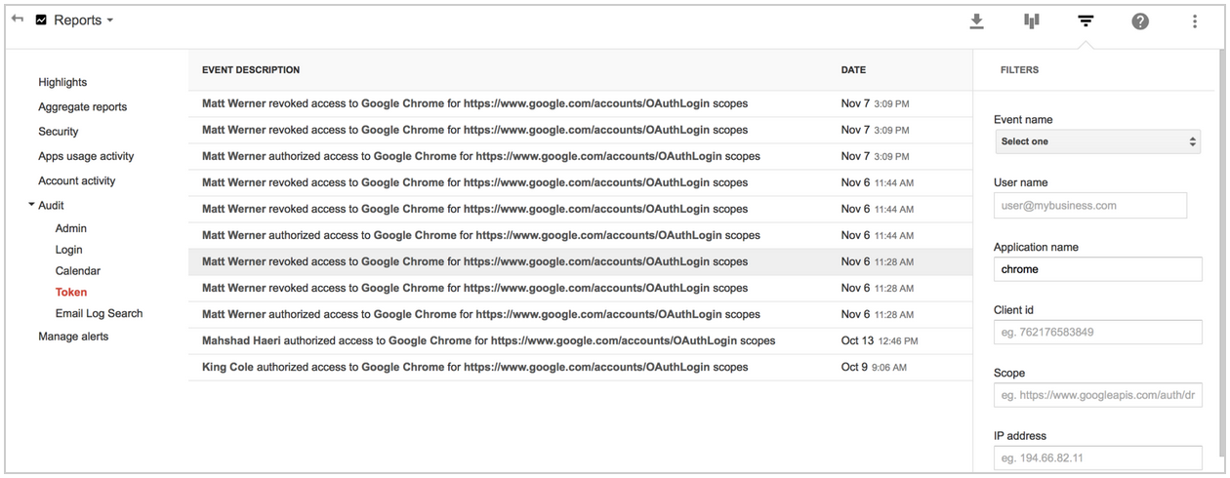

How it works: Admins can use this new audit report to find out what new apps have been installed by individual users and, if needed, can revoke access using the security tab. This improves admin visibility and control over access of third party apps by users in their domain.

In addition, admins can use the Reports API to set up a push notification for oAuth 'authorize' and 'revoke' events, generating an alert when a certain event happens. Optionally, admins can also revoke data grants using the Directory API.
To access the OAuth audit reports in Admin console, click on Reports > Audit > Token.

Check out the Help Center to learn more.

Admin provisioning of individual Google+ profiles
Released November 18, 2014

What’s new: Previously, Google Apps administrators had no means by which to give people in their organizations a Google+ profile in order to connect with other employees and encourage collaboration and sharing in the organization. With this launch, admins can now perform individual profile upgrades centrally (bulk upgrades coming soon).

How it works: For people with Google+ enabled who have yet to register (i.e., create a profile), admins may individually create a basic Google+ profile on their behalf, certifying the employee is 18+ years of age (or specifying a birthday). After the admin has completed this action, the person for whom the profile was created will receive a Google+ welcome email explaining the action taken by the admin.

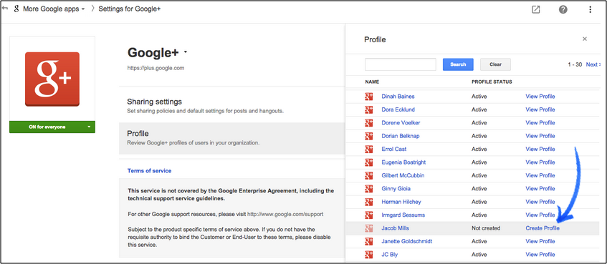

Note: This launch applies to Premier, Gov and higher-education EDU domains only (K-12 EDU domains are excluded). People using Picasa or with a public chat photo are not eligible to be upgraded by an admin, and must create their own profile.

To learn more, check out the Help Center (admin info | user info) and the Google for Work G+ post.

Admin control of link sharing for Hangouts video calls
Released November 20, 2014

What’s new: In October, we launched the ability for Google Apps customers to share links to Hangouts video calls so that external guests may request to join if not explicitly invited. This helps guests avoid errors when joining with alternate Google accounts.

We’re now giving admins greater control over this feature with an option in the Admin console to start all video calls in a state where external participants may request access to join. This feature is especially useful for customers who do not rely on Google Calendar to schedule meetings or those using the Microsoft Outlook Hangouts plugin.

How it works: To adjust the setting, click on Google Apps > Talk/Hangouts > General Settings:

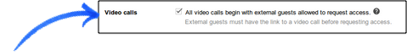

To learn more, check out the Help Center.

New tools to help improve online security
Announced November 24, 2014 Share with your organization

What’s new: To help improve online security for Google Apps users, and to make admins’ jobs a bit easier, we launched two new security tools to help Google Apps users take more control of their security online.
A new Devices and Activity dashboard gives your users additional insight over the devices accessing their Google account.  The page shows a comprehensive view of all devices that have been active on an account in the last 28 days, or are currently signed in. And in case any suspicious activity is noticed, there’s a setting to immediately take steps to secure an account and change a password. | 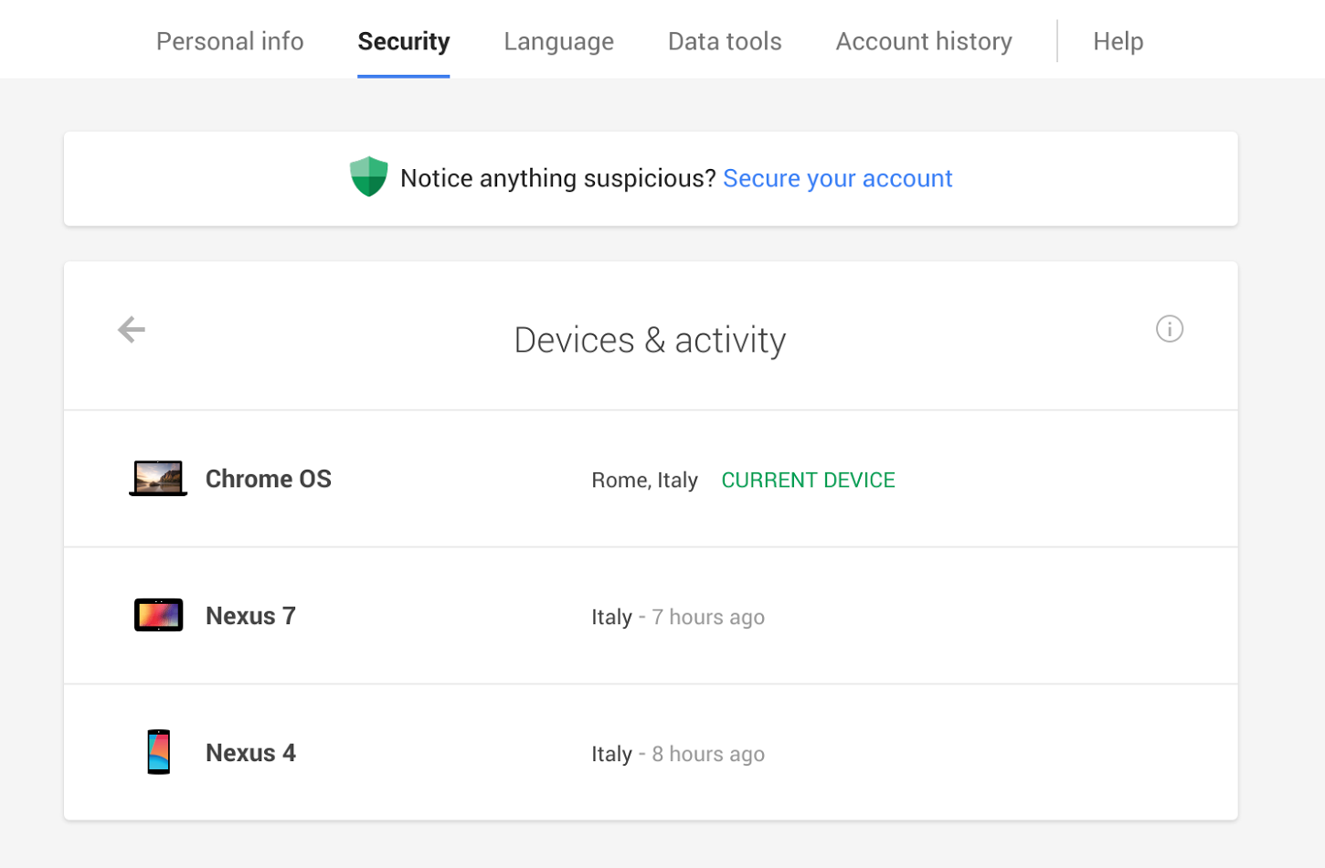
We also launched the security wizard for Google for Work accounts. The security wizard guides users through steps they can take to turn on or adjust security features, like providing contact info for account recovery (if the
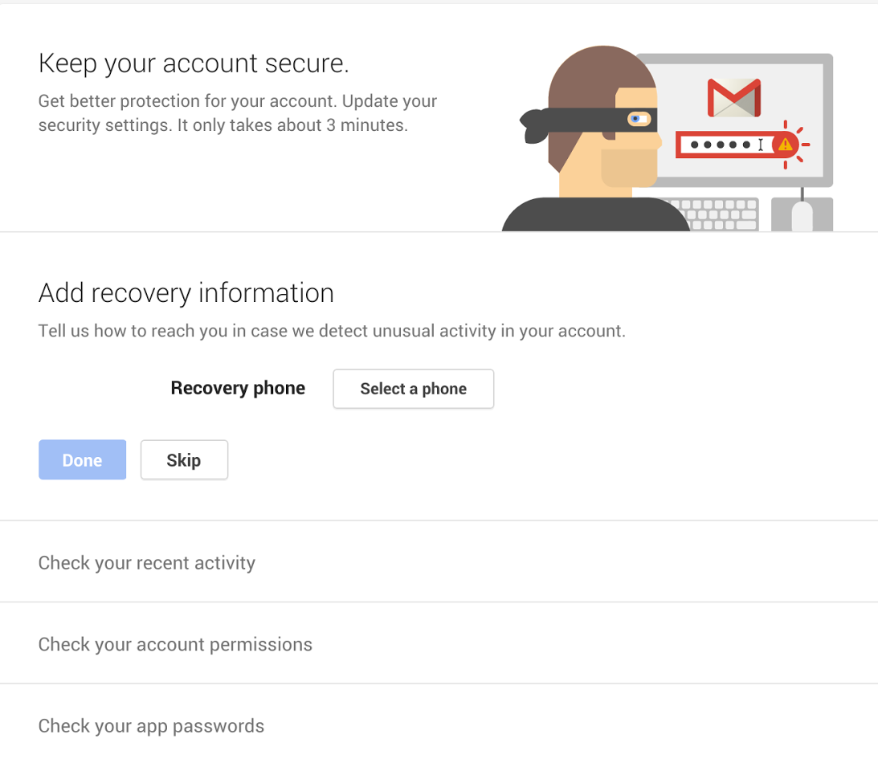 | domain security policy allows it), or reviewing recent account activity and account permissions. Plus, it only takes minutes for users to update their settings.  This tool prioritizes all administrator settings for security features that users are permitted to turn on. The wizard can be accessed at g.co/accountcheckup.  To learn more, check out the Google for Work blog post.

Learn more about Google Apps

Google Apps for all: The Apps Show on YouTube, every Wednesday, 11am PST
Share with your organization

What’s new: In November, in addition to the normal schedule, The Apps Show aired its first episode of “The Apps Show Asks”, interviewing Lucas Pettinati, UX Lead for Google Apps, about upcoming material design changes. Debbie and John continued to present news and demos on Google Apps, covering topics like collaboration, publishing and using Calendar for the holiday season.  To know: Let us know what topics you would like us to cover in future episodes by commenting on our latest episode. We’d love to know what your users need, or where you’d like to drive adoption.  Bookmark The Apps Show playlist on YouTube | 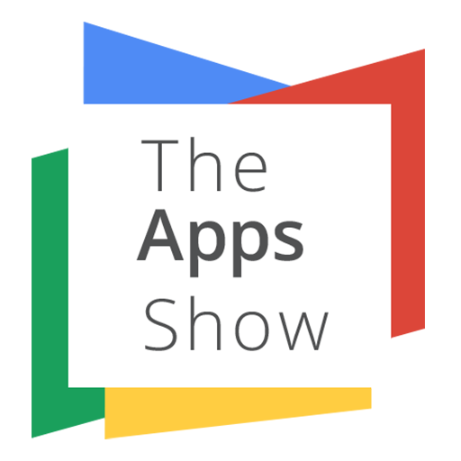

What’s New for Apps Admins videos
Share with your organization
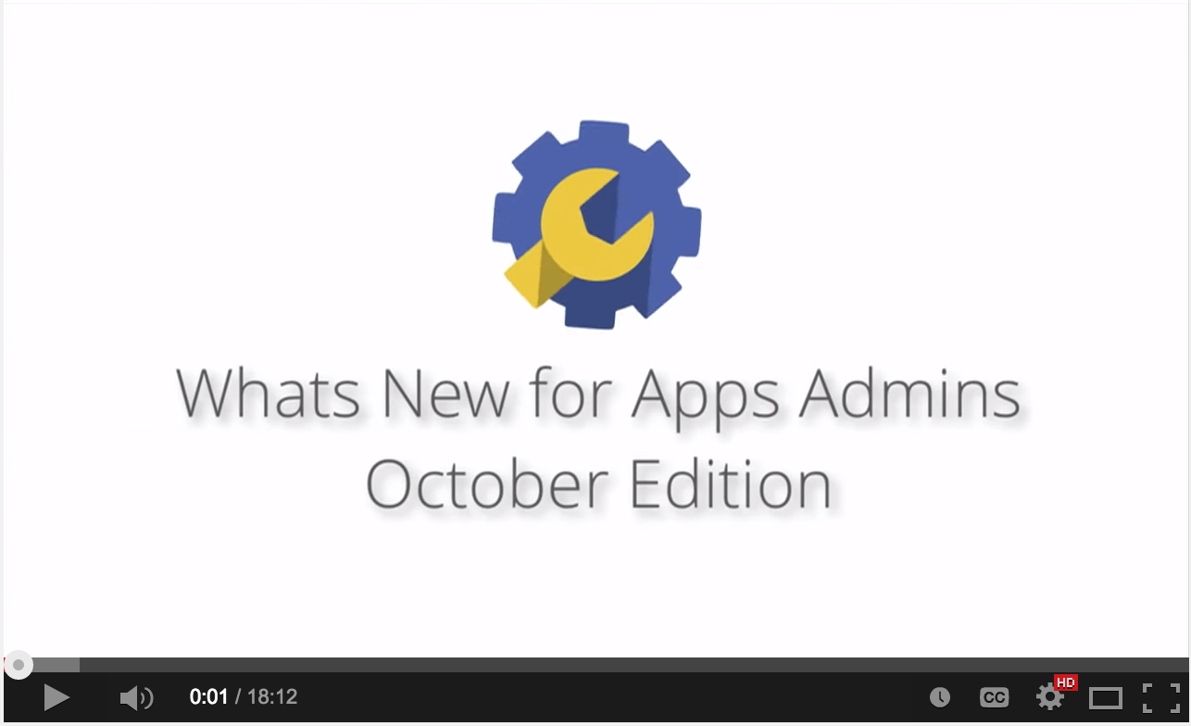 | What’s new: We’ve changed the format of (and renamed) our popular What’s New in Google Apps webinar series from scheduled live sessions to video recordings hosted on YouTube, so you can watch and share them whenever you want.  How it works: The What’s New for Apps Admins videos provide a recap of all of the features we've released in the past month that are relevant to Google Apps Admins.

Bookmark the playlist on YouTube and check back each month for the latest updates. You can also access all video recordings in the archive on the What’s New site.

Google Apps Learning Center: Top 10 tips for Sales and Marketing professionals
Share with your organization
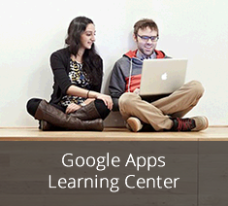
What’s new: We interviewed Sales and Marketing executives across the world to find out how they use Google Apps to work faster and collaborate better. Check out their Top 10 Google Apps tips and share them with your Sales and Marketing users! Then, let us know what you think.

To know: The Google Apps Learning Center is a training site that helps Google Apps for Work users learn how to use product features, increase productivity, and work better together.

Visit the Google Apps Learning Center for more training resources you can share with your users.

Thanks for checking out our newsletter!
We’d really appreciate your thoughts on how we can make this work best for you.

