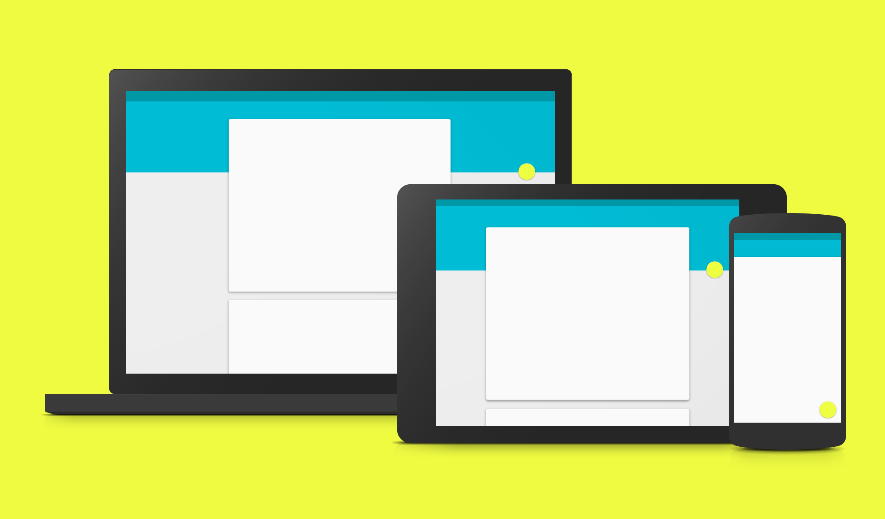 | Featured Launch: Material Design  A new, unified experience coming to Google products

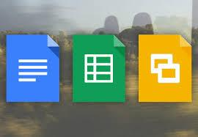 | Work together  Feature improvements to Google Classroom  Manage revisions for non-Google files in the new Google Drive  Google Drive for Education: Unlimited storage

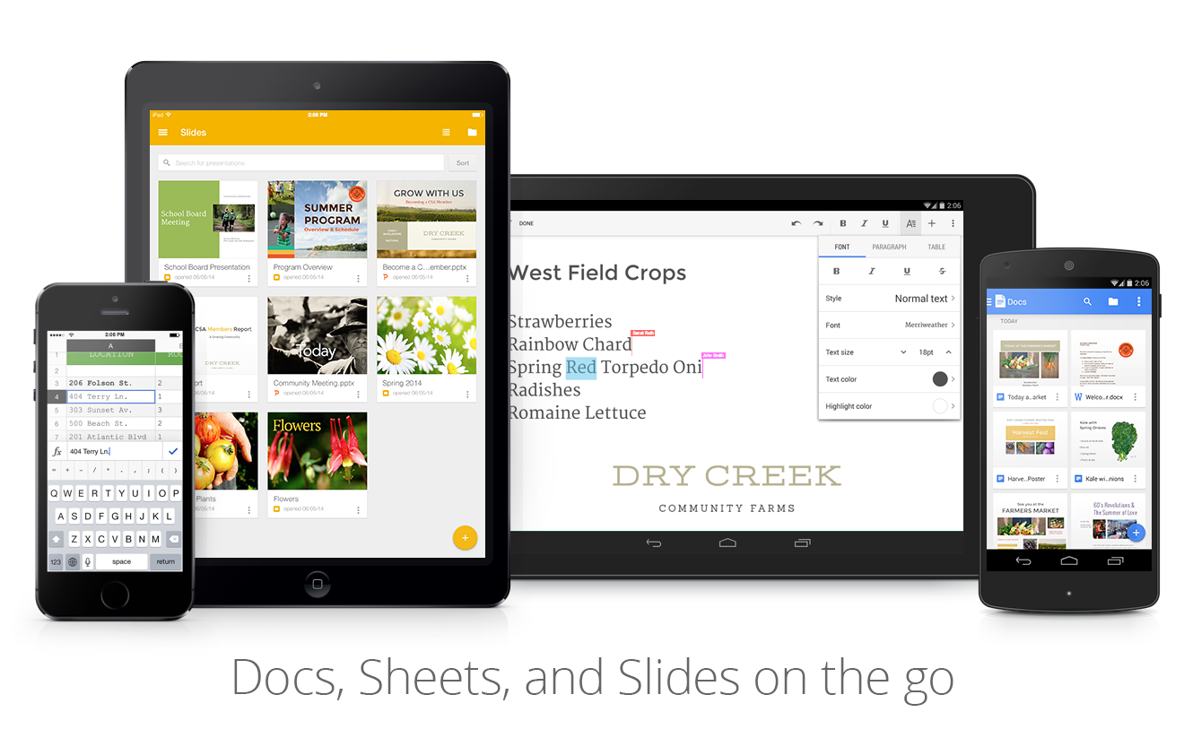 | Work anywhere  Incoming view, other new features for the Docs, Sheets, and Slides apps  Better search, sleeker design, and more for the Google Drive app for Android

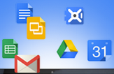 | Simple to use  Easier guest access to Hangouts video calls  Adjust image color and filters in Google Slides  Spell check in the new Google Sheets  Google+ Polls  New Hangouts Chrome app  Add-ons for Google Forms

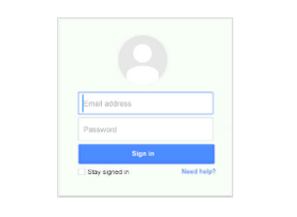 | Business ready  Restore deleted Drive and Gmail data  Installable triggers to add-ons for Google Docs and Sheets  Admin SDK Reports API limit extended to 15 months  Improvements to email log search in Admin console  Aggregate reports added to Admin console reporting  Enhanced Google Admin app for Android

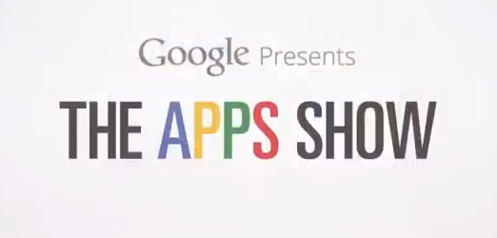 | Learn more about Google Apps  The Apps Show on YouTube  What’s New in Google Apps webinar video recordings

We’d really appreciate your thoughts on how we can make this newsletter work best for you.

-The Google Apps Team
November 4, 2014

Featured Launch: Material Design

A new, unified experience coming to Google products
Share with your organization

At Google I/O in June, we introduced material design, a single underlying design system that allows for a unified experience across platforms and device sizes. It features smooth animations and transitions between screens, a multi-layered interface with quick access to the elements that you need most often, and a colorful UI with diverse fonts and styles.

Material design principles have begun to appear in recent Google product launches, including Google Classroom, the Docs, Sheets, and Slides home screens and mobile apps, the Drive Android app, Android Lollipop and the new Gmail and Calendar Android apps. You’ll continue to see more consumer and Work products adopting these new design principles across platforms in the coming weeks and months.

To help with this UI transition, we have created an instructional guide [pdf] outlining the key features and functional elements of material design. We've also created an overview [pdf] of the new Gmail Android app features and user experience. Check them out and share them with your organization.

Work together

Feature improvements to Google Classroom
Released October 14, 2014 Share with your organization

What’s new: Google Classroom launched this summer to make Google Apps for Education even simpler—saving teachers time and making it easier to collaborate with students. In October, we launched five improvements to Classroom, focusing on things educators and students around the world told us were most important to them: | 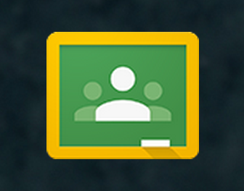

- Groups integration: Ability to pre-populate classes using existing Google Groups. If your school uses tools like School Directory Sync, admins can sync class rosters from the student information system (SIS) into Groups.
- Mark assignments as “done”: Students can mark assignments as complete even if there's nothing to turn in (e.g. watch a video, read a chapter, bring something to class).

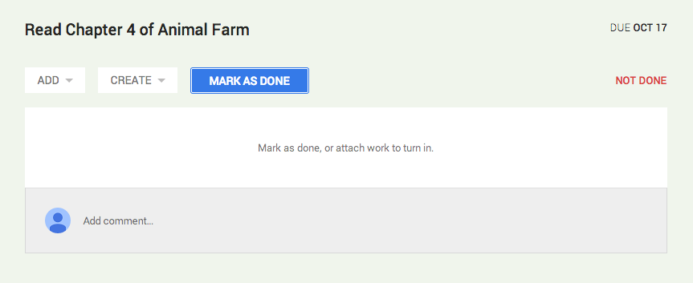

- Export all grades: Teachers will now have the ability to download grades for all assignments at once, making it easier to export assignments to any gradebook.
- Sorting: Teachers can now choose to sort students by first or last name, depending on their needs.
- Greater teacher controls: Teachers can now set permissions for whether or not their class can post or comment in the stream, they can mute individual students from posting or commenting and can even view previously deleted items in the stream.

Check out the Google for Education blog post to learn more.

Manage versions of non-Google files in the new Google Drive
Released October 22, 2014 Share with your organization
What’s new: As available with the old version of Google Drive, we’ve now incorporated the option to view and manage versions for non-Google file formats in the new Google Drive.  How it works: Simply right-click on a non-Google file in Drive (or click on it and use the ‘More Actions’ menu in the toolbar), and select ‘Manage versions.’  Check out the Help Center to learn more. | 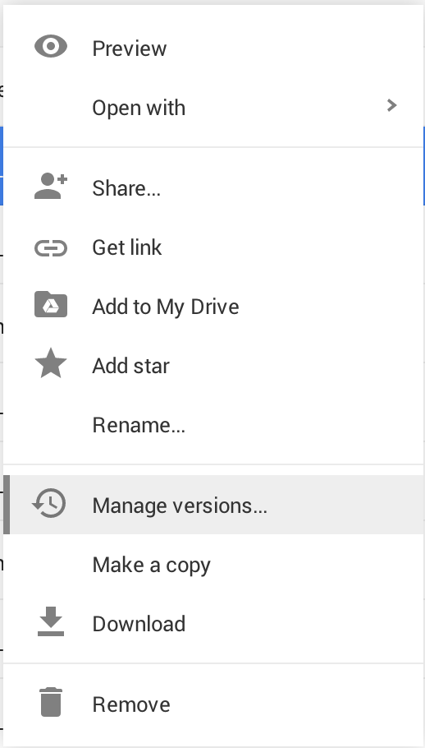

Google Drive for Education: Unlimited storage
Released October 28, 2014 Share with your organization
What’s new: Last month we announced that we’d bring Drive for Education to the Google Apps for Education platform, adding the features below to all Google Apps for Education accounts at no charge:
- Unlimited storage: Store as many Google Drive files, Gmail messages, and Google+ photos as you need. Individual file sizes up to 5TB will be supported.
- Vault: Use Google Apps Vault to archive emails and chats, to search Drive files, and to preserve important information for your organization.
- Enhanced auditing and controls: Gain insights from new activity and audit reports for Google Drive.

On October 28th, we announced that the first of these features—unlimited storage—was added to all Google Apps for Education accounts. The remaining features are coming soon.

Check out the Google for Education blog post to learn more.

Work anywhere

Incoming view, other new features for the Docs, Sheets, and Slides apps
Released October 21, 2014 (iOS) | October 29, 2014 (Android) Share with your organization

What’s new: People using the Google Docs, Sheets, and Slides apps on both Android and iOS will now see a new Incoming view added to the navigation panel, similar to the one in Drive today, granting quick access to files that have been shared with them.  How it works: As with other available views, by touching the menu button next to a file in Incoming they can perform a number of actions, including:  - Share  - Download  - Move to a folder in Drive  - Print  - Remove | 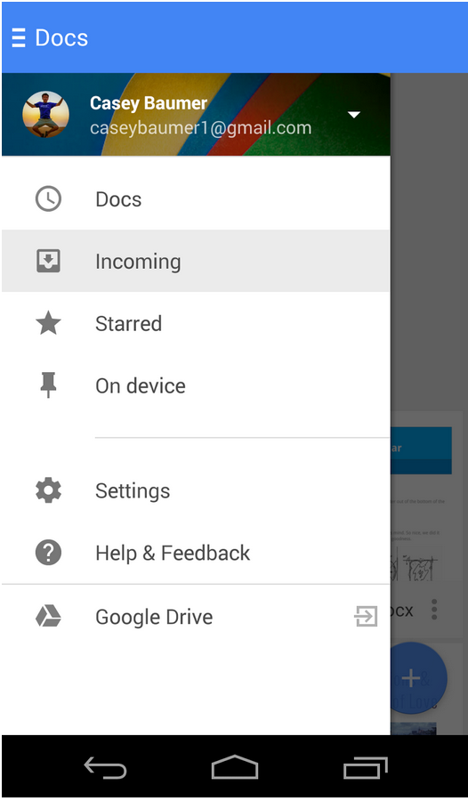
Other features: Other new features added this month include the ability to make copies of Google documents, spreadsheets, and presentations (Android only, coming for iOS) and various usability, accessibility and performance improvements across both platforms.

For iOS: check out the Help Center to learn more and get the Google Docs, Sheets, and Slides iOS apps in the App Store.

For Android: check out the Help Center to learn more and get the Google Docs, Sheets, and Slides Android apps on Google Play.

Better search, sleeker design, and more for the Google Drive app for Android
Released October 29, 2014 Share with your organization

What’s new: A new version of the Drive Android app is now available on Google Play. The launch includes:

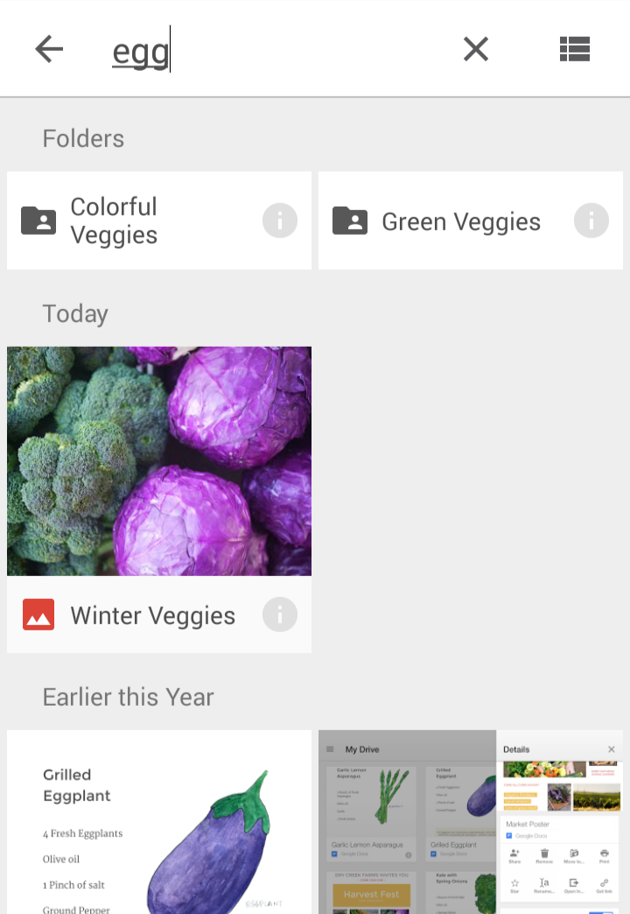 | - New Design: The new interface, leveraging some of the material design principles recently announced, puts your content front and center and makes creating, uploading and accessing it easier than ever.  - Improved Search: The search tool makes it easy to find the content you’re looking for by updating results as you type each letter into the search box.  - Better Sharing: Add a custom message when you share a file so your collaborators know why you sent it. You can also turn on link sharing to make the file “public” and set access to view, comment, or edit. This automatically copies the link to the clipboard and allows you to paste it wherever you want.  - Enhanced PDF Viewer: A new PDF viewer lets you find, select and copy text in PDFs, and it’s built right into Drive so you don’t need to launch another app.

Learn more in the Google for Work blog post and get the Google Drive App on Google Play

Simple to use

Easier guest access to Hangouts video calls
Released October 2, 2014 Share with your organization

What’s new: This launch allows Google Apps customers to share links to Hangout video calls so that external guests may request to join if not explicitly invited. This will also help your guests avoid errors when joining with alternate Google accounts.

For example, a person using Hangouts for Work invites another contact to a Hangout via calendar, but the contact connects through their browser, already logged in with their personal account.

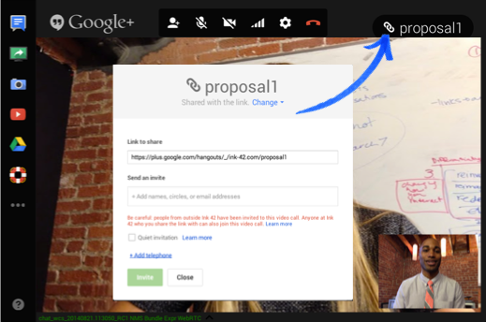
How it works: Features of the launch include...

- People in the same domain as the Hangout can make the video call externally accessible with the link.
- Video calls that are shared with the link require someone in the Hangout Apps domain to accept those requesting access.

Check out the Help Center for more information.

Adjust image color and filters in Google Slides
Released October 6, 2014 Share with your organization

What’s new: People working with images in Google Slides on the web now have the ability to adjust their color, transparency, brightness, and contrast.
How it works: To use this feature, select an image in Google Slides and click the Image options button in the toolbar (you can also right click on the image, or use the Format menu, and select Image options). Under "Recolor," you can change the color of your image to match your presentation. Under "Adjustments," you can change the following:

- Transparency: How much of the slide shows through behind the image
- Brightness: How bright the image appears on the slide
- Contrast: How much the image stands out from its background

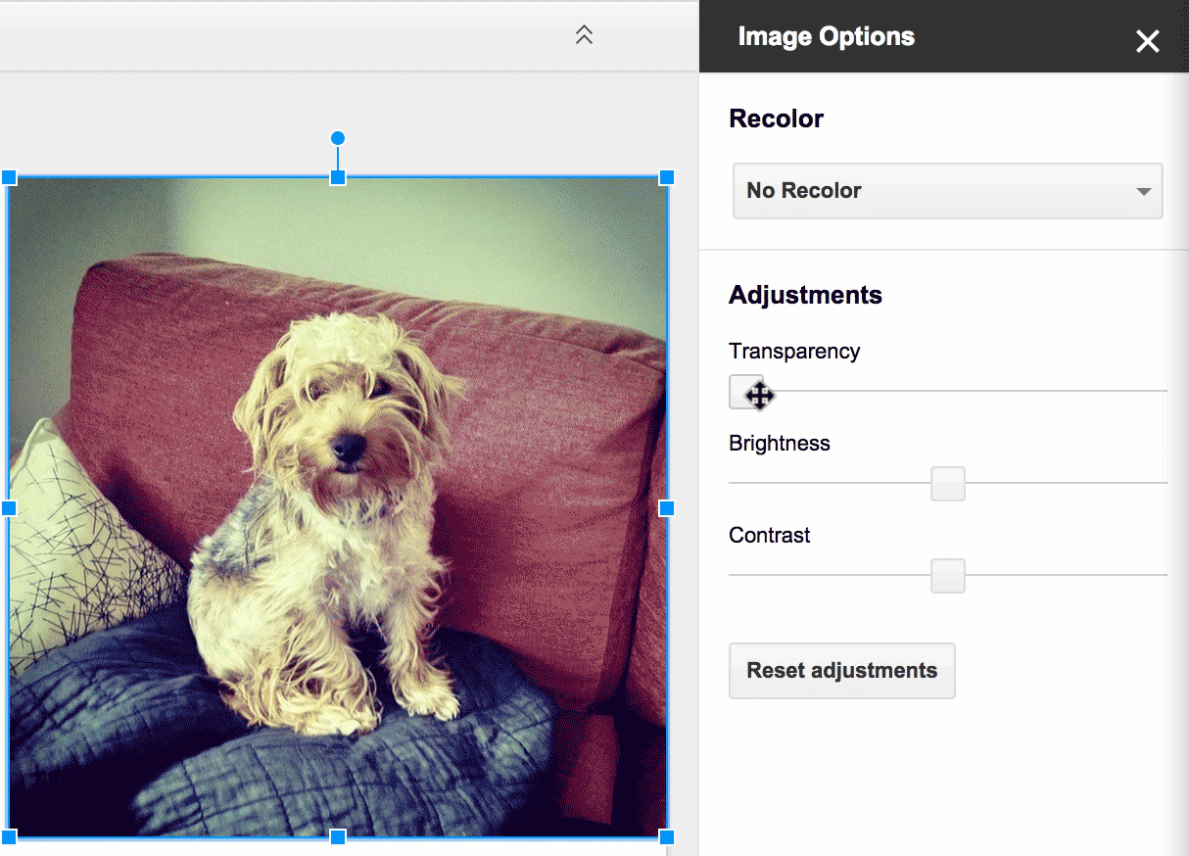

Check out Drive blog announcement and the Help Center to learn more.

Spell check in the new Google Sheets
Released October 9, 2014 Share with your organization

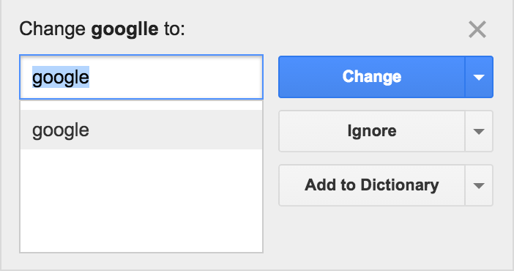 | What’s new: We have added spell check functionality to the new Google Sheets. This is a new and improved version of spell check compared to what existed in the old Sheets.  In this version, spelling is checked against the web (similar to Docs and Slides) so that the dictionary is always up-to-date. Also like in Docs and Slides, people can add words to their own dictionary so that the spell checker won't mark names or abbreviations as misspellings in the future.
How it works: You can access the functionality by selecting Tools -> Spelling. Incorrect words are featured in a window on the upper right corner of the screen, along with suggested spellings. Suggestions can be accepted or ignored.

Check out the Help Center to learn more.

Google+ Polls
Released October 9, 2014 Share with your organization
What’s new: We launched Google+ Polls, a new feature that allows people using Google+ to create interactive polls and share them with their friends and followers.  How it works: Images can be added to the polls from one’s device or Google+ photos, making them interesting and engaging. Followers can then vote on the polls and results are visible to them after they vote.  Polls are now available on Android and the web, and are coming soon to iOS. Look for the new poll icon when creating a post to create a poll.  Check out the Help Center and G+ announcement to learn more. | 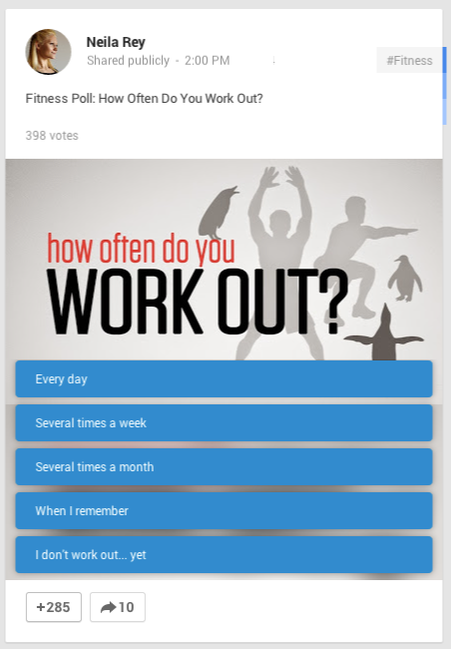

New Hangouts Chrome app
Released October 9, 2014 Share with your organization

What’s new: A new Hangouts Chrome app was launched with an updated UI. The app is available for Windows and Chrome OS platforms and brings the best of Hangouts to your desktop.

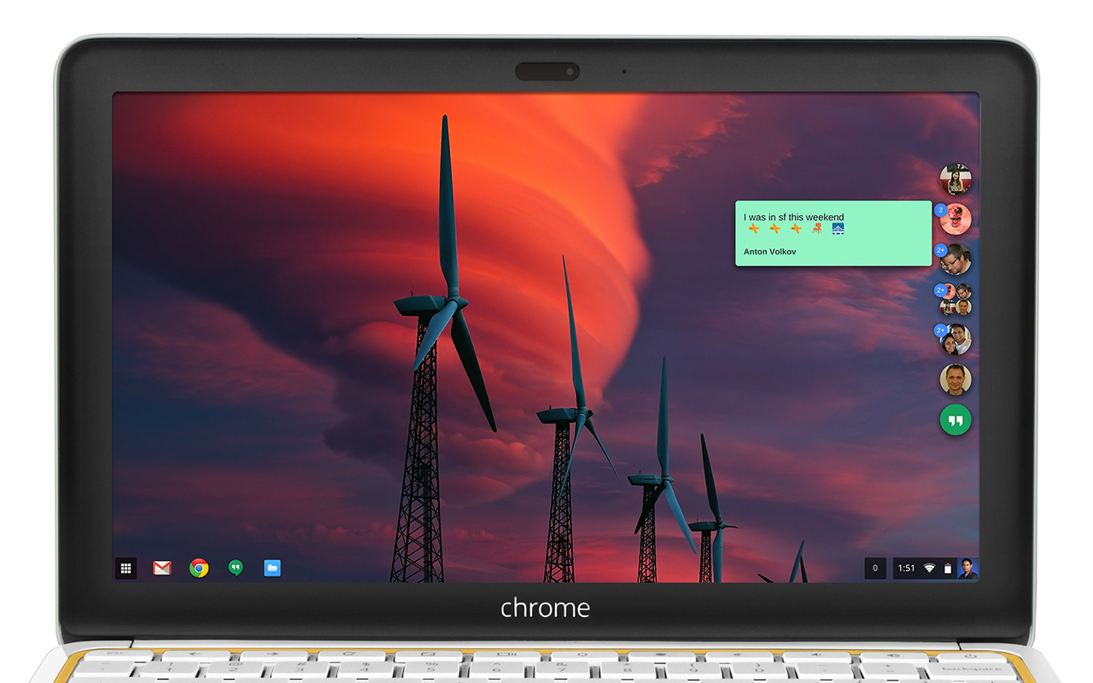

Improvements include:
- Streamlined design that keeps your chats accessible without getting in the way of everything else. Your contact list and all your chats are condensed into one easy to toggle window.
- Works outside of your browser so your chats are always available, not tucked away inside a window. You’ll get all your messages as long as you have the app running, and your chats will sync across Hangouts on all your devices.
- Includes all the video and voice features you’re used to in Hangouts. We recently announced you can make phone calls to any number in the world (via Hangouts dialer) and now you can do this right from your desktop. If you use Google Voice, the app includes complete Google Voice support, so you can make and receive calls, and get your voicemails and SMS messages directly in Hangouts.

For more information:
Chrome Blog post
Help Center
Download the Hangouts Chrome app

Add-ons for Google Forms
Released October 23, 2014 Share with your organization

What’s new: In the spirit of giving you even more flexibility and customization, we launched add-ons for Google Forms—new tools, created by developer partners, that bring even more features to your surveys (just like add-ons for Docs and Sheets).
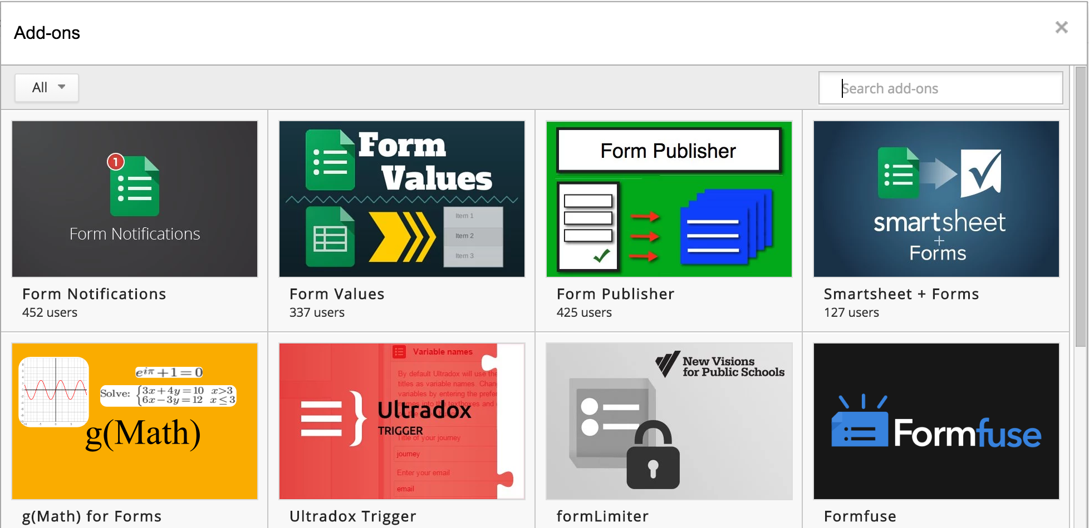
How it works: Check out the growing list of available add-ons, several of which are particularly relevant for education, from the “Add-ons” menu in Forms, or by directly visiting the Forms add-ons store.

If you have already disabled add-ons for your domain in the Admin console, Forms add-ons will be defaulted off. To change this setting, click on Google Apps -> Drive > General Settings and check/un-check the “Allow users to install Google Docs add-ons” box.

Check out the Google for Education blog post and the Help Center to learn more.

Business ready

Restore deleted Drive and Gmail data
Released October 1, 2014 Share with your organization

What’s new: Previously, admins could restore deleted Drive content for individual people in their domain using the Admin console. This launch adds the ability to restore Gmail messages that were inadvertently deleted as well and return them to user inboxes. This helps ensure that, if a person accidentally deletes important data, that data is not permanently lost.

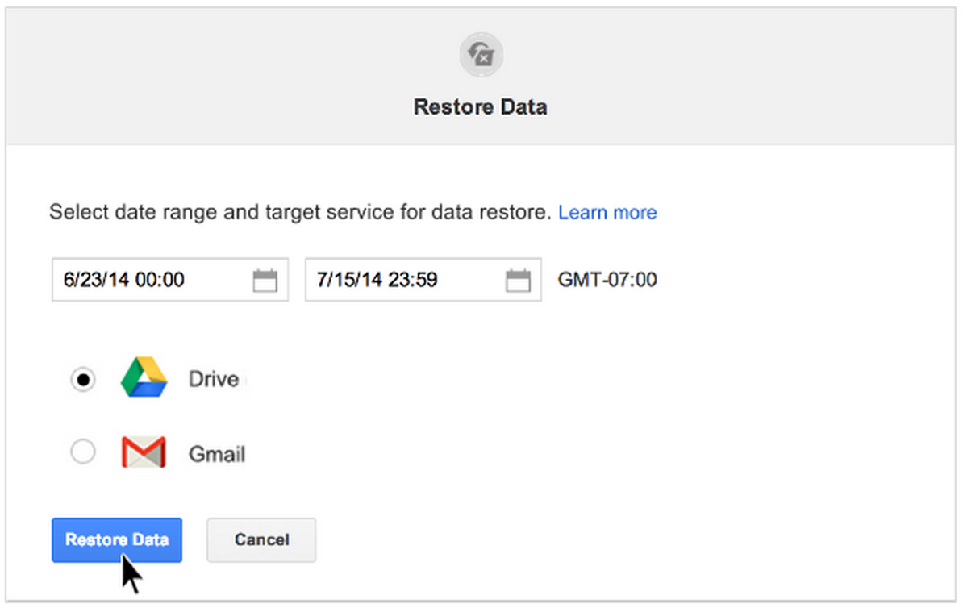
How it works: Admins can perform Drive or Gmail data restores for up to 10 people simultaneously, and can restore data from up to 25 days in the past. From Admin console, click Users, select the names of the individual(s) whose data you want to restore and click the undelete button.

Check out the Help Center to learn more.

Installable triggers to add-ons for Google Docs and Sheets
Released October 1, 2014

What’s new: Earlier this year, we introduced add-ons for Google Docs and Sheets—packaged Apps Script projects that people can easily install from our add-on store to get extra functionality and features.  Since then, plenty of developers told us they were eager to add installable Apps Script triggers to their add-ons, and now they can do just that. For example, a Sheets add-on can now react when a person submits a response to a Google Form, or can call a method that requires authorization when a person edits a cell.  How it works: If you've worked with installable triggers before, you'll find that they behave a little differently in add-ons, so be sure to check out the documentation.  Check out the Apps Update blog post to learn more. | 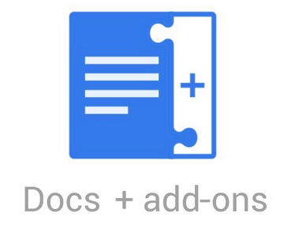  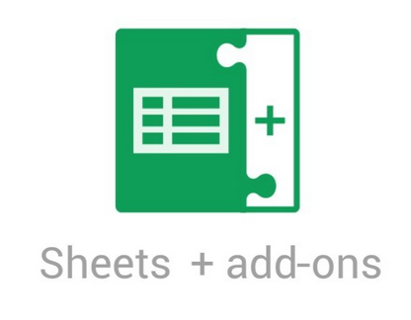

Admin SDK Reports API limit extended to 15 months
Released October 10, 2014

What’s new: In an effort to provide more historical App usage reporting data for admins, we recently extended the time limit for application usage activity reporting data provided by the Admin SDK Reports API from 6 months to 15 months.

Note: this change does not apply to the application usage activity reports in the Admin console Reports UI, nor does it apply to the Audit reports API or Admin console Audit UI, which will remain at the current 6 month limit.

How it works: The limit extension began when this feature was officially implemented on September 2, 2014, so the full 15 month (450 day) history will be available on May 30, 2015, with an earliest available record date of March 6, 2014. For example, if you attempted to pull an Apps usage activity report today via the API, you would get a little over 7 months worth of data.

Check out the Reports API Revision History to learn more.

Improvements to email log search in Admin console
Released October 15, 2014

What’s new: Email log search gives admins the ability to sift through the delivery logs for their domains and evaluate message transit. This is useful for tracking down a sender or recipient's missing messages, such as those that have been quarantined as spam or otherwise routed incorrectly. Admins also use this tool to determine the IP addresses sending and receiving mail or troubleshoot how policies affect mail flow.

We launched several improvements to email log search, including:
- Displaying compliance rule executions  - Allowing export of log search results to Google Sheets  - Note: the export/download button has moved from above and below the search results to the upper right of the screen (see screenshot to right)  - Correct list expansion when the sender or recipient changes  - Note: Admins should anticipate seeing more details appear in messages where information changes during the lifecycle of a message  - Improving visibility of message transit time  - Time is now shown per recipient on the message details page  - Label and informational message changes | 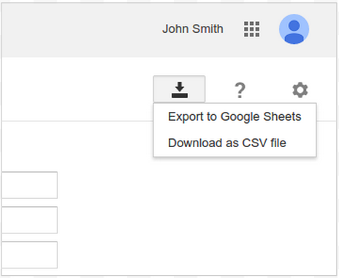  New export button location
How it works: To access email log search, click on Reports -> Audit -> Email Log Search from Admin console.

Check out the Help Center to learn more.

Aggregate reports added to Admin console reporting
Released October 20, 2014

What’s new: We have added a new feature to Admin console reporting called aggregate reports. The aggregate reports are designed to provide domain-level trends across multiple apps and allows admins to select their favorite reports for regular tracking.  The first version contains a series of charts displaying Google+ Hangouts usage, account status, admin status, storage quota, document visibility, email count, and Drive file count for all people within your Google Apps domain.  How it works: These new reports are best used for seeing overview trends. The user-level reports should be used for detailed user-level data. Admins can easily export the report directly to a Google Sheet or download it as CSV.  We will soon be adding many more reports to this section like usage trends for mobile, mail spam reports and many others so stay tuned. | 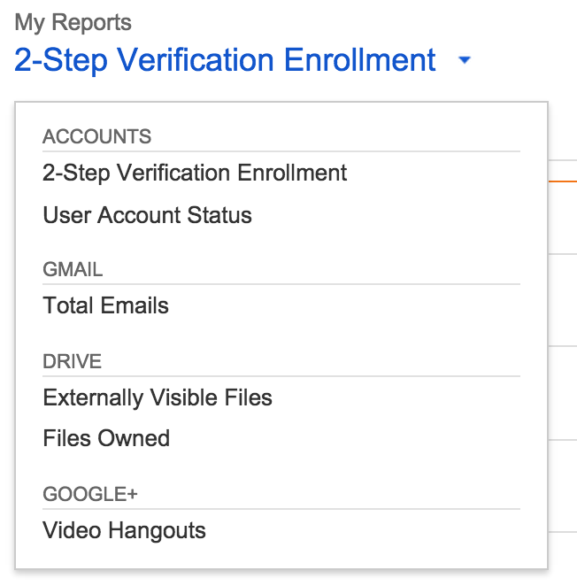

To access the aggregate reports, sign in to the Admin console and click Reports > Aggregate Reports.

Check out the Help Center to learn more.

Enhanced Google Admin app for Android
Released October 30, 2014

What’s new: The Google Admin app for Android allows super admins to manage their Google for Work products on the go with their Android phones and tablets. The app can be used to manage users and groups, contact support, view audit logs, check notifications and do other common administrative tasks.

We rolled out an update to the app, including the following new features:

- Optional 4 digit PIN that works across devices: We’ve added an optional and convenient 4 digit PIN to secure access to the app. You can use the same PIN while logging into the app from any device.
- Ability to switch between multiple accounts: Admins who manage multiple domains can now do so from the app without logging out and logging in
- Accessibility compliance: The app is now accessibility compliant on all the primary flows and use cases
- New icons and other fixes: The app now features new sharper icons; several bugs have been fixed

Note: this app works for super admins only and requires API access to be enabled.

Get the app in the Play Store and check out the Help Center to learn more.

Learn more about Google Apps

Google Apps for all: The Apps Show on YouTube, every Wednesday, 11am PST
Share with your organization

What’s new: In October, The Apps Show launched its second season. Debbie and John presented the Apps news, shared tips and tricks to make the best of Forms, Groups, and Sheets and showed how Googlers collaborate.  To know: The audience continues to love The Apps Show. Engaging comments and Google+ shares keep flowing in. Make sure you promote The Apps Show internally and let us know what topics you would like us to cover in future episodes.  Bookmark The Apps Show playlist on YouTube | 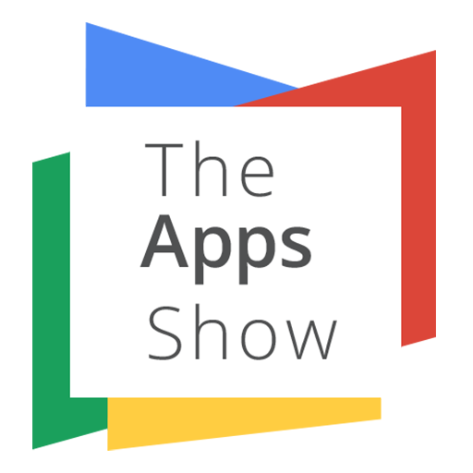

What’s New in Google Apps webinar video recordings
Share with your organization
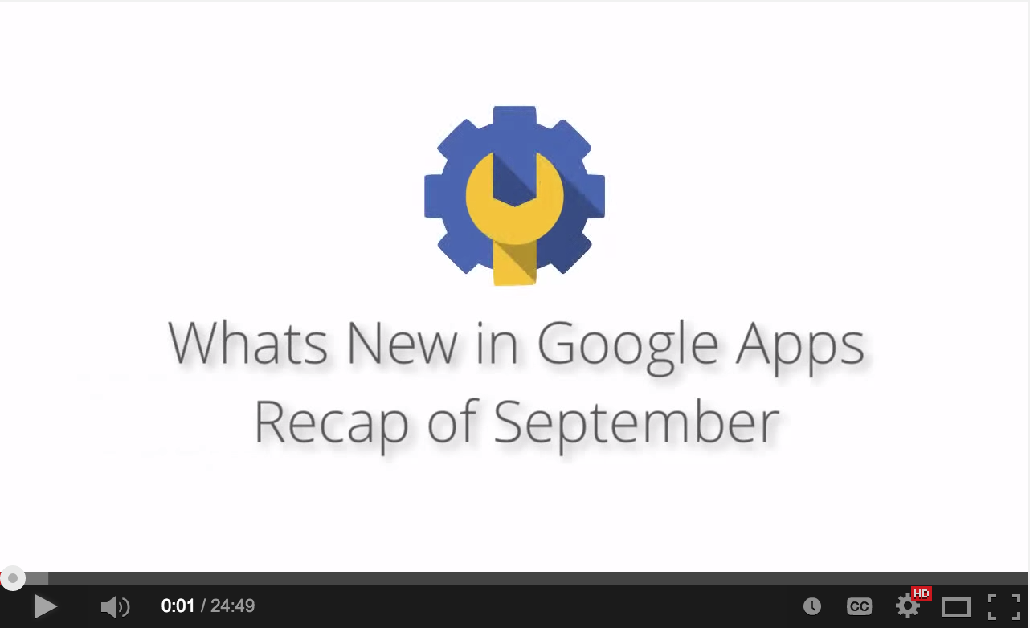 | What’s new: We’ve changed the format of our popular What’s New in Google Apps webinar series from scheduled live sessions to video recordings hosted on YouTube, so you can watch and share them whenever you want.  How it works: The What’s New videos provide a recap of all of the features we've released in the past month (think of it as a video version of this newsletter).
The recap of September launches is currently posted and the October recap will be posted in the second week of November. Moving forward, you can access all video recordings in the archive on the What’s New site.

Bookmark the webinar archive page and check back each month for new recordings.

Thanks for checking out our newsletter!
We’d really appreciate your thoughts on how we can make this work best for you.

